| Hallowed Magicians |
| --- |
| Sewer Game |
| **“Escape from the Sewers”** |
| Version #01  All work Copyright © 2020 by Hallowed Magicians Games.  All rights reserved. |
| **Seth Rodger Patterson, Myan Brissett, Shemal Grey, Kishon Arulchelvam** |
|  |

| October 22th 2021 |
| --- |

**Table of Contents**

[Your Table of Contents should go here. Make sure that your document’s sections are hyperlinked to their corresponding pages.]

**Version History**

[This is where you keep track of the detailed changes made to your document throughout the course of development.]

* Seth Rodger Patterson, Oct.22: Starting: Game Overview, Mechanics,Camera,Game World,Items
* Myan Brissett, Oct.22: Controls,Mechanics,Start Menu, Level Selection, Logo, Level design
* Shemal Grey, Oct.22: Score

1. **Game Overview**

* *The game begins when the main Character wakes in a dark & mysterious sewer*
* *The Player must complete a series of puzzles:*
  + *Key Gathering*
* *Once completing all puzzles they are allowed to go free, and win the game.*

1. **Game Play Mechanics**

* *Jumping*
* *Wall Jump*
* *Key collection*
* *Door activation*

1. **Camera**

* *Side Scroller*
* *Head camera movement*

1. **Controls**

*(Which keys does your game use? Does it use the mouse or a joystick?)*

* *Movement : move right = D key, move left = A key,*
* *Crouch = S key*
* *Climb = W key*
* *Jump : Space bar*
* *Double Jump: Space bar x2*
* *Interact (to open doors, or pick up items) = E key*

1. **Saving and Loading**

*A Save/Checkpoint is created when completing a level.*

1. **Interface Sketch**

*(What does the game interface look like? Provide a screenshot or sketch)*

1. **Menu and Screen Descriptions**

* *the games menu screen will give a simple start and exit menu*
* *when the play clicks on start it will then send them to the level selection*
* *once the player selects the level of their choice they will then be put into the stage*

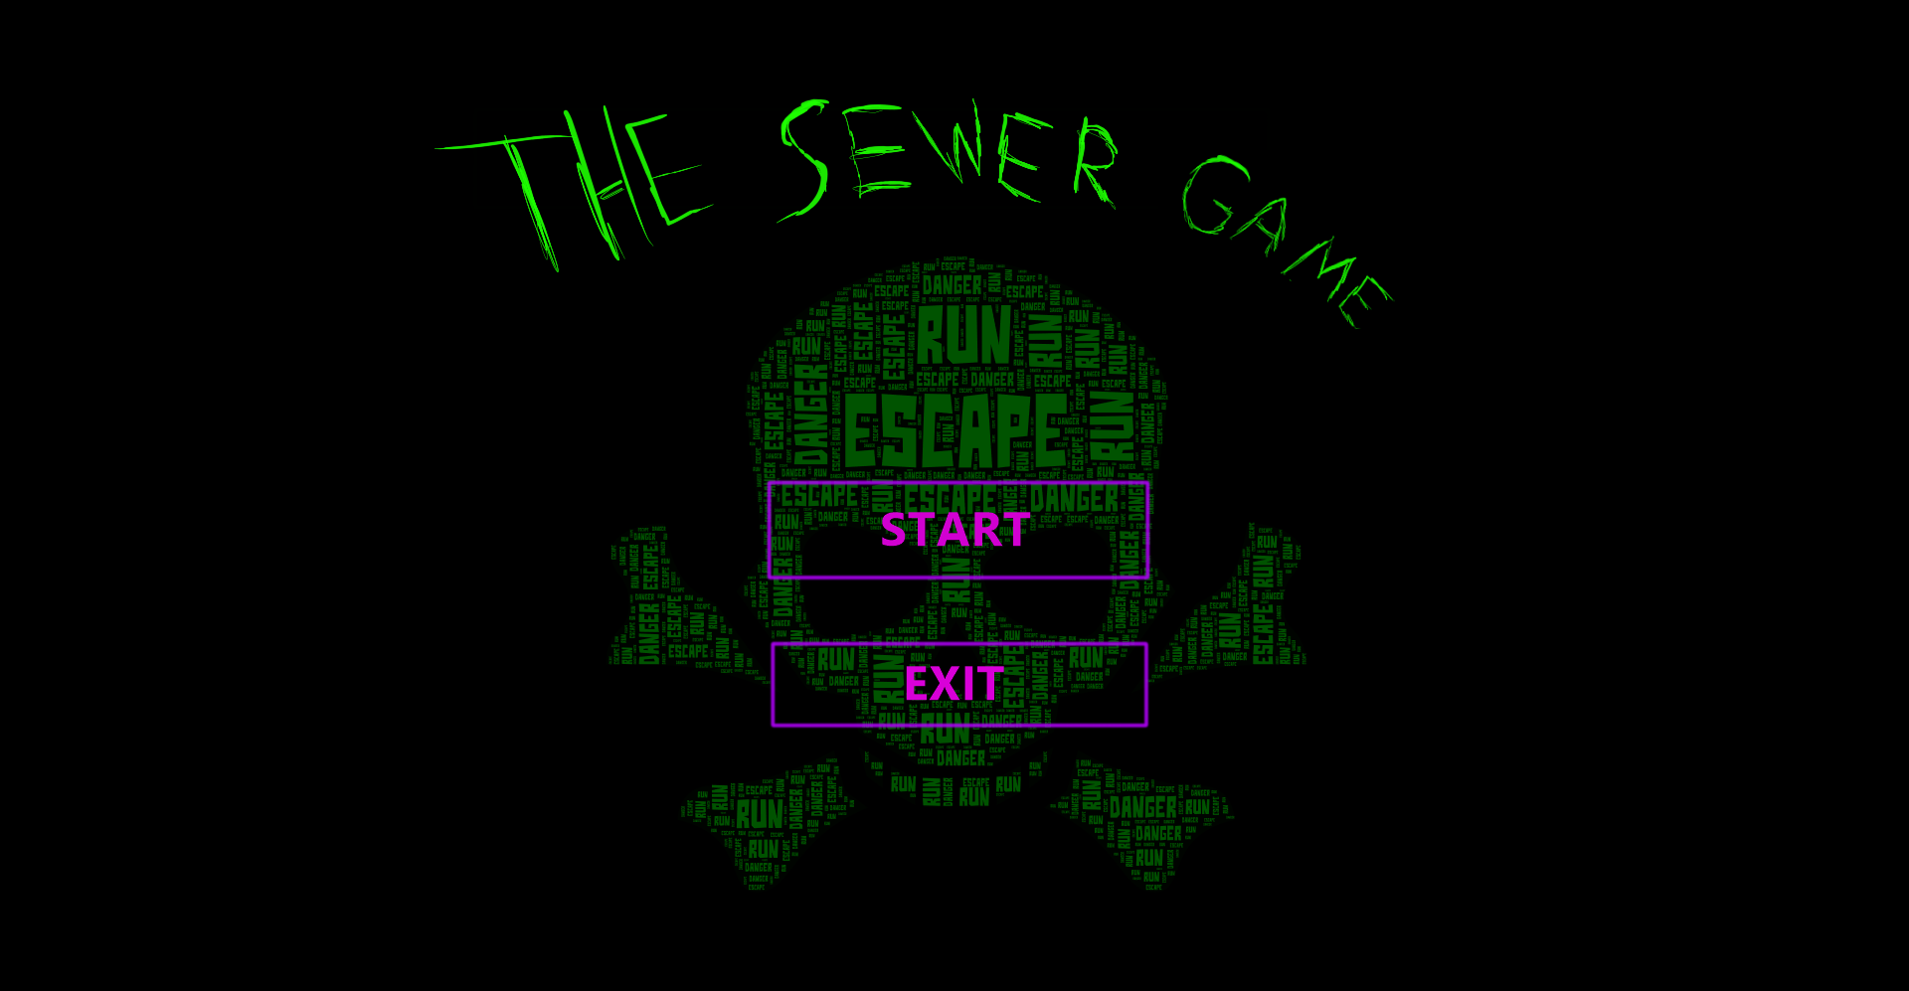

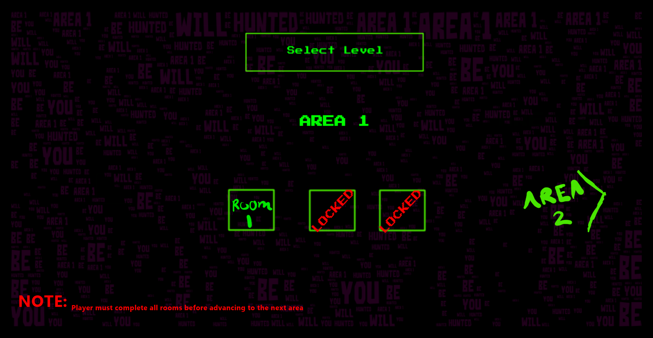

1. **Game World - CREATIVITY!**

* *Mossy underground passageways*
* *Dark and dank atmosphere*
* *Water Canals/ pipes*

1. **Level**

* *The level will begin with your player starting at the bottom of the sewer.*
* *The player will traverse through the various rooms/areas in the stage, completing puzzles and obstacles along the way*
* *There are no checkpoints within this level (subject to change). The player must also complete the level within its time limit.*
* *Failing puzzles, being hit by dangerous/hazardous objects or running out of time will all result in players death.*

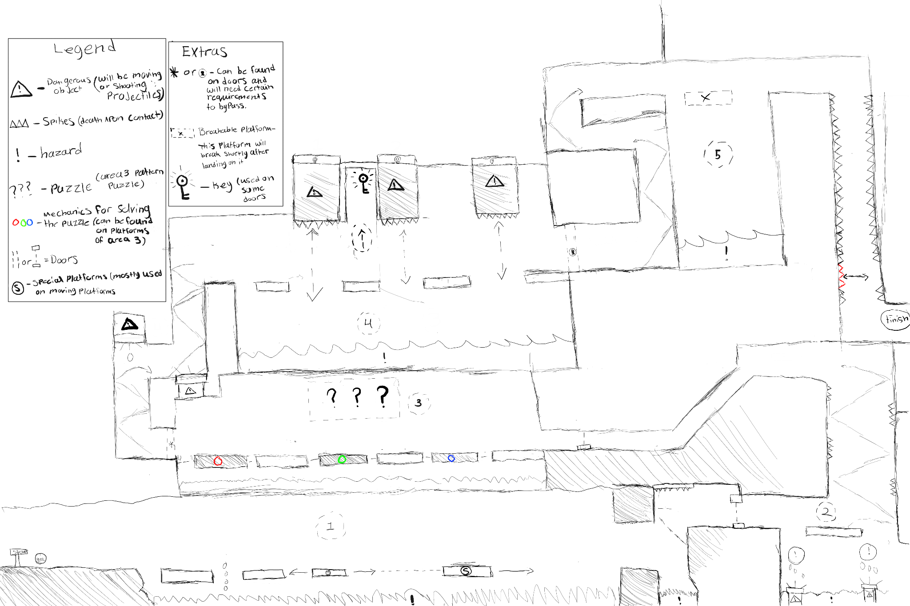

1. **Game Progression**

* Player grabs keys on his way through levels

1. **Character**

* *An average looking dude*
* *Blue pants, hoodie, brown hair*

1. **Non-player Characters**

N/A

1. **Enemies**

*N/A*

1. **Weapons**

*N/A*

1. **Items**

* *Key, a special item allowing the player to leave the area*

1. **Abilities**

*N/A*

1. **Vehicles**

N/A

1. **Script**

*N/A*

1. **Scoring**

*The level is timed. Clear the level with the best possible time amounts to higher leaderboard rankings.*

1. **Puzzles/Mini-games**

N/A

1. **Bonuses**

*WIP*

1. **Cheat Codes**

*WIP*

1. **Sound Index**

*WIP*

1. **Story Index**

*Protagonist wakes to find himself in a dark room, as he explores he finds he must be in a sewer of sorts. He must then complete a series of gauntlets, created or simply coincidently made to challenge his escape. Once he does so he can return to the surface and Escape the Sewer.*

1. **Art / Multimedia Index**

*Wip*

1. **Design Notes**

*(Include additional design notes here)*

1. **Future Features**

*N/A*